Modelling Assembly and Simulation of Treadle Sewing Machine

Geometric Model-

Design and mechanism-
The Stitching Mechanism-
The lock stitch approach is very different from ordinary hand-sewing. In the simplest hand stitch, a length of thread is tied to a small eye at the end of a needle. The sewer passes the needle and the attached thread all the way through two pieces of fabric, from one side to the other and back again. In this way, the needle runs the thread in and out of the fabric pieces, binding them together.
While this is easy enough to do by hand, it is extremely difficult to pull off with a machine. The machine would have to release the needle on one side of the fabric just as it grabbed it again on the other side. Then it would have to pull the entire length of loose thread through the fabric, turn the needle around and do the whole thing in reverse. This process is way too complicated and unwieldy for a simple machine, and even by hand it only works well with short lengths of thread.
Instead, sewing machines pass the needle only part-way through the fabric. On a machine needle, the eye is right behind the sharp point, rather than at the end. The needle is fastened to the needle bar, which is driven up and down by the motor via a series of gears and cams. When the point passes through the fabric, it pulls a small loop of thread from one side to the other. A mechanism underneath the fabric grabs this loop and wraps it around either another piece of thread or another loop in the same piece of thread.
The most important element of a lock-stitch mechanism is the shuttle hook and bobbin assembly. The bobbin is just a spool of thread positioned underneath the fabric. It sits in the middle of a shuttle, which is rotated by the machine's motor in synch with the motion of the needle.
Just as in a chain-stitch machine, the needle pulls a loop of thread through the fabric, rises again as the feed dogs move the fabric along, and then pushes another loop in. But instead of joining the different loops together, the stitching mechanism joins them to another length of thread that unspools from the bobbin.
When the needle pushes a loop through the thread, the rotary shuttle grips the loop with a hook. As the shuttle rotates, it pulls the loop around the thread coming from the bobbin. This makes for a very sturdy stitch.
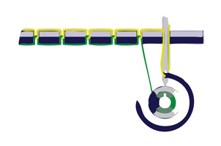
Feed mechanism-
The drop feed mechanism is used by almost all household machines and involves a mechanism below the sewing surface of the machine. When the needle is withdrawn from the material being sewn, a set of "feed dogs" is pushed up through slots in the machine surface, then dragged horizontally past the needle. The dogs are serrated to grip the material, and a "presser foot" is used to keep the material in contact with the dogs. At the end of their horizontal motion, the dogs are lowered again and returned to their original position while the needle makes its next pass through the material. While the needle is in the material, there is no feed action.
Thread Unwinding mechanism-
A slot is cut out on the main rotor arm of the sewing machine on a raised part to give us a profile on which the part latches on and moves accordingly. This mechanism is important because the thread tends to keep wrapped onto the spool until and unless it is subjected to some tension. This facilitates the stitching mechanism by ensuring that it is carried out perfectly.
Feet Control mechanism-
It ensures easy usability of the manual sewing machine and the user is promptly able to control the working speed of the sewing machine.
All the mechanisms have been modelled on Pro-engineering/Creo Parametric. They have also been simulated on Animate add-on for Creo.
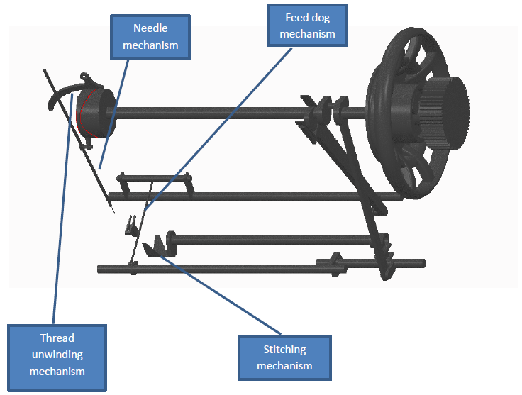
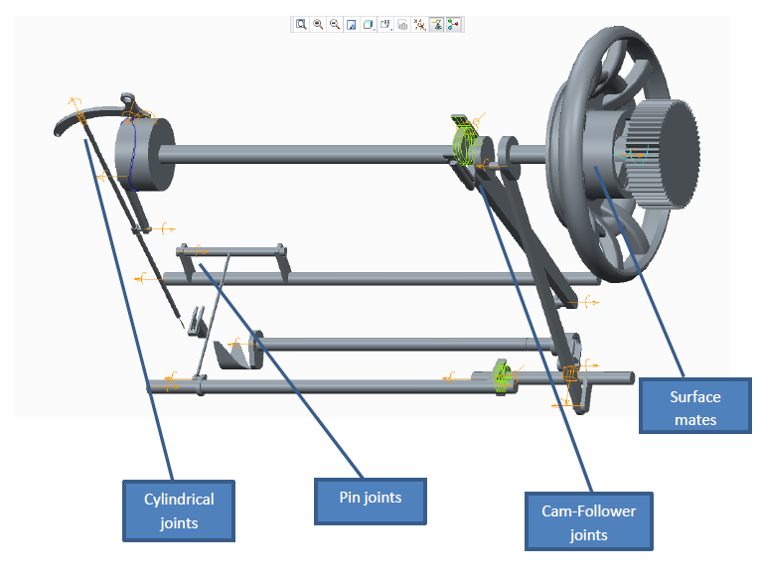
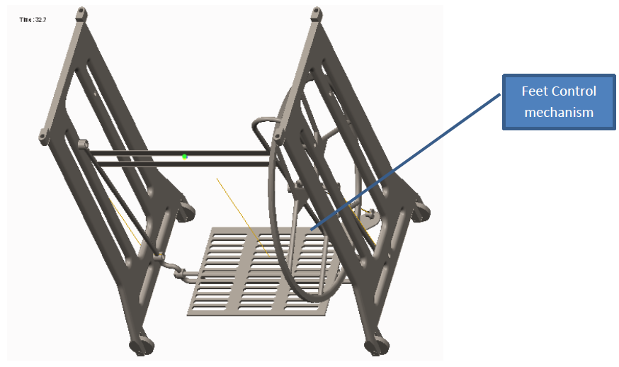

Rendered model with materials applied

